The Pizza Parlor Web Site Specifications

## OVERVIEW OF WEB SITE REQUIREMENT

The Pizza Parlor website consists of a front-end ordering system that captures order details and customer delivery information and a backend portion that supports simple processing of incomplete and completed orders that can be accessed by an administrator. This Pizza Parlor also has database connection capabilities via MySQL and PHP. In addition to other web tech used to produce both the back-end and front-end of this website include jQuery, javascript, html5, css3 and foundation5 framework.

## LIST OF PAGES

Front-end Pages: Ordering the pizzas will take place through these pages

* home.php
* order.php
* checkout.php
* orderplaced.php

Admin Pages: Order viewing and processing will take place through these pages.

* Log-in.php
* admin.php
* addadmin.php
* manage_users.php
* incomplete.php
* completeOrder.php
* completeToday.php

Create Database (only done in the beginning once):  
create_db.php

## Website File Structure and Layout

### File Structure Folders

Base – contains php base files such as the menu or header/footer

CSS – contains all the stylesheets

JS – folder for javascript   
  
DB – contains the database file

### Website Layout

The layout is simple and clean with a complimentary color scheme.

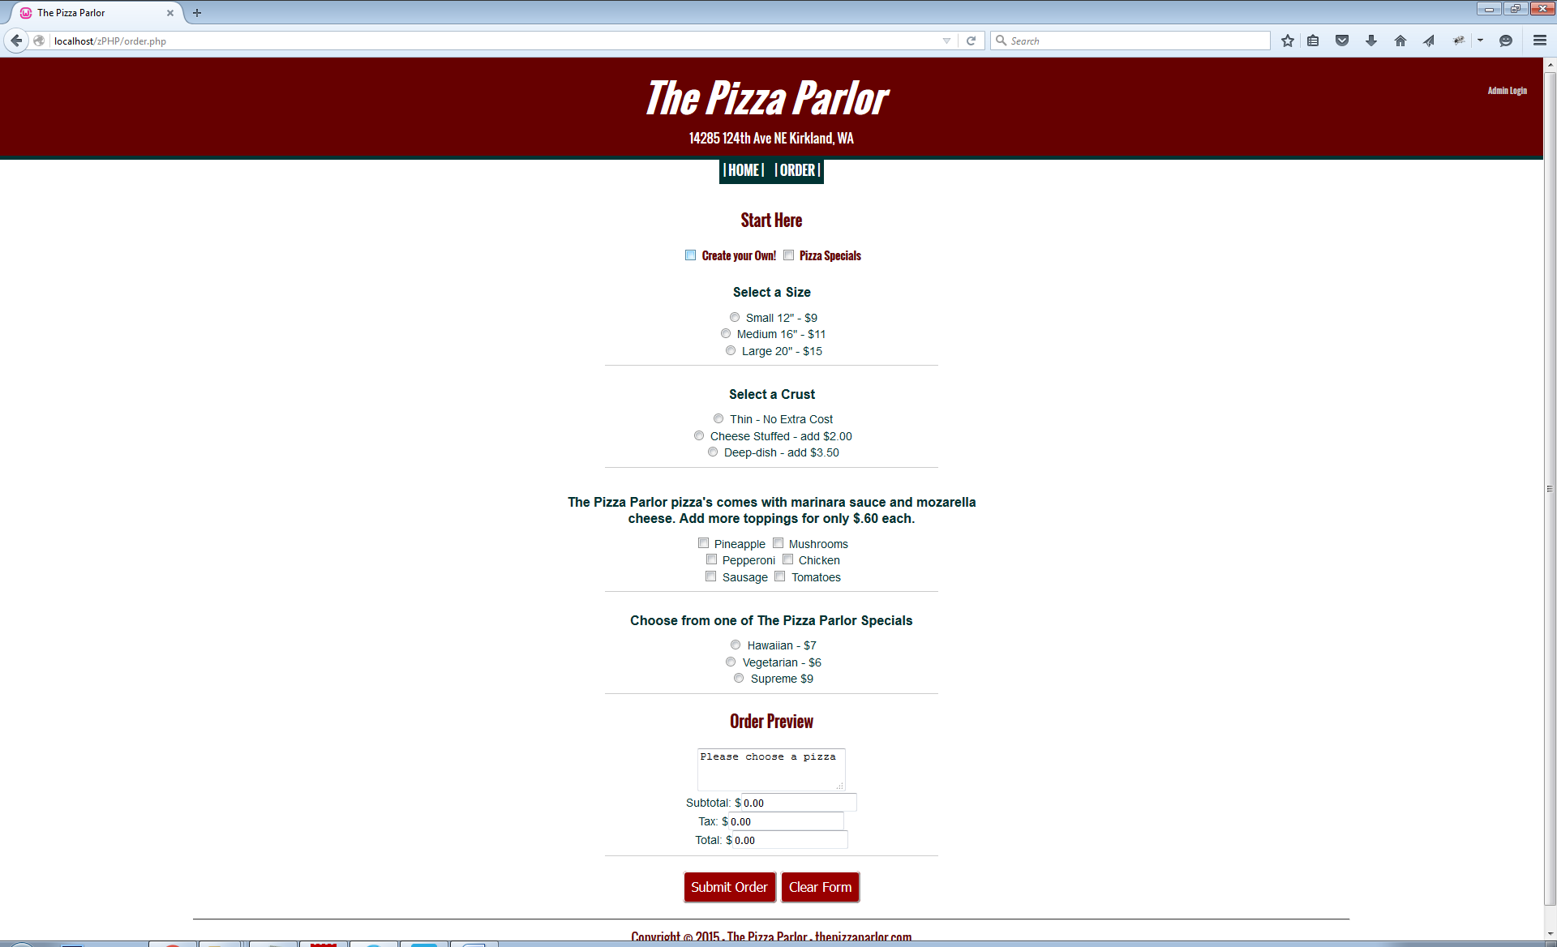The color scheme consist of Teal# #003333 and Dark Red #660000, per the branding requirements for the Pizza Parlor

Font: San Serif TypeFace

All files are available for preview at: **ftp://bucket.sandbox.edcc.edu/corr5794/CIS243/PizzaParlor**

## Navigation Structure

Navigation

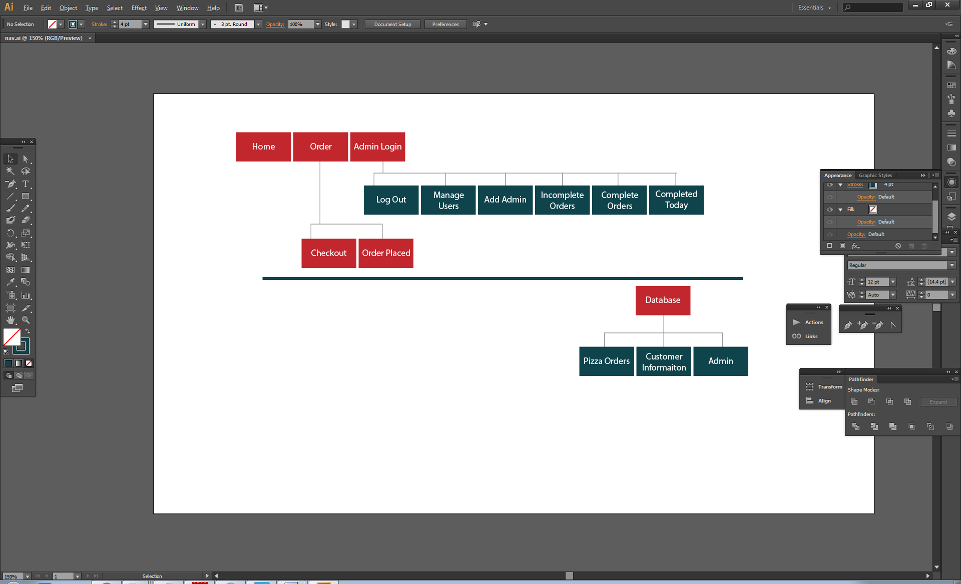

## Database Diagram

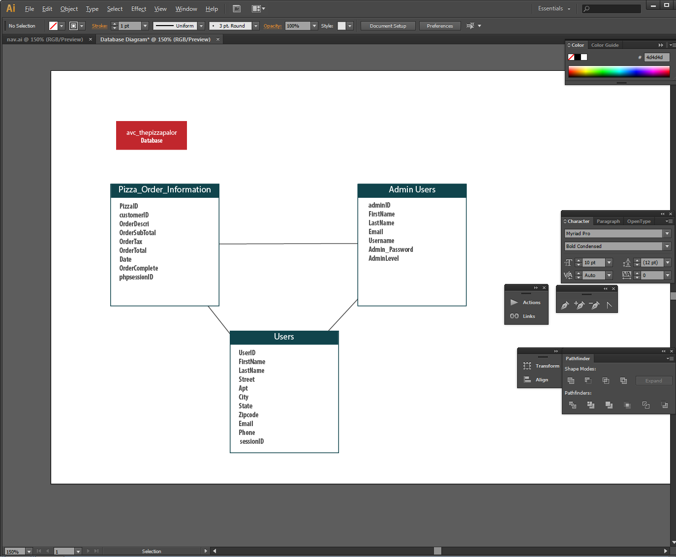

## Admin Instructions

1. To view orders, click admin login on the top right hand side the default login is:

U: Admin, P: Pizza when the database is created.

1. Entering your username and password will take you to the admin menu.

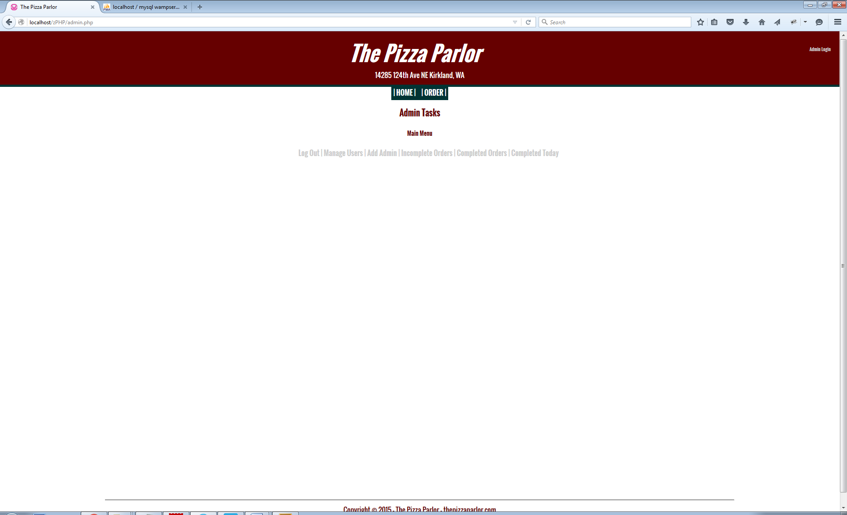

1. To view incomplete orders, click the Incomplete Orders. Update the order from the menu below using the order ID and Entering Y for yes, if the order is complete.

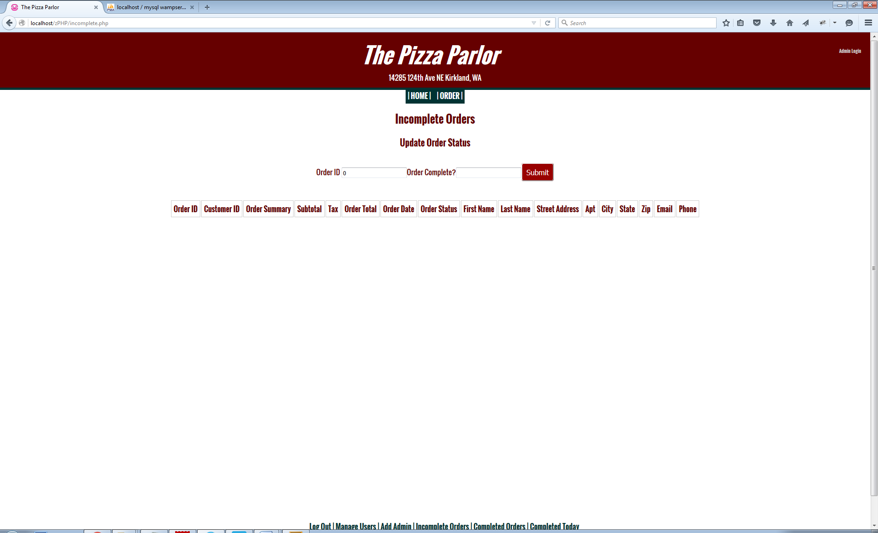

1. To view complete orders, click on Completed Today in the admin menu.
2. To view orders completed today, click on Complete Orders in the admin menu.
3. To remove inactive admin users, click on the delete Users button in the admin menu and enter the Admin ID to remove inactive admin users.

